**Figure 1**

*Student socioeconomic status*

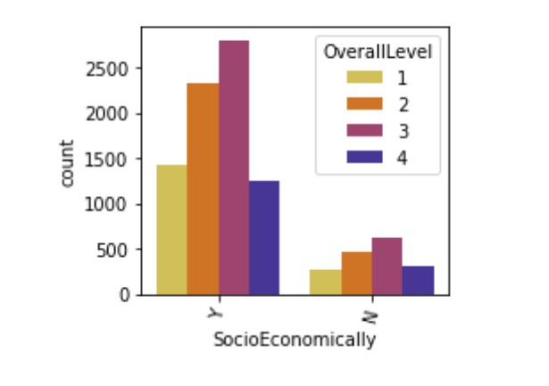

**Figure 2**

*Student housing status*

